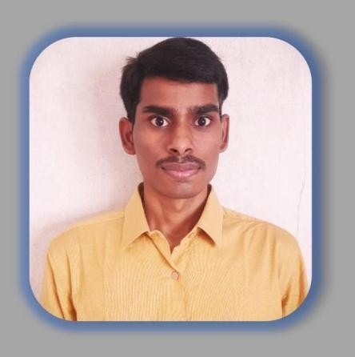

**Kummetha Adi Narayana Reddy**

**MERN Stack Developer**

Contact :

[g-mail :](mailto:djangomvtadi@gmail.com)

**+91 9398895448**

**[akumatha@gmail.com](mailto:reactjsadi@gmail.com) https://[www.linkedin.com/in/adi019471/](http://www.linkedin.com/in/adi019471/)**

**<https://github.com/Adi19471/>**

**<https://portfolio-adi-website.web.app/>**

# Professional Summary

A Focused and dedicated individual with a specialization in MERN stack. Self- driven and curious, with a keen interest in building user friendly designs. Looking forward to being a part of a work environment that provides opportunities for self-development and career growth.

**Technical Skills as a Full-stack Developer:-**

* **Web Development Stack: Express JS, React JS & Node JS**
* **Programming Languages: JavaScript (ES6+)**
* **Front-End: React.js, HTML5, CSS3, Material-UI, Bootstrap, reactstrap**
* **Back-End: Node.js, Express.js,Python,Django**
* **Databases: MongoDB**
* **RESTful APIs, JSON Web Tokens (JWT)**
* **Version Control: Git, GitHub**
* **IDE : VSCode, Subline ,webstrom**
* **Operating System :Windows**
* **Agile/Scrum Methodologies**
* **Problem-Solving and Debugging**
* **Strong Communication and Collaboration Skills**

# Work Experience:

# Project-1:

## **Project :-** Organization Profile Management Application

**Project Description:** Organization Profile Management Application

This application is an in-house project used by the per-sales and sales team to maintain and access data related to existing customers and prospective customers to enable strategic planning of sales activities of ZettaMine for their IT services and solutions division.

**Modules Worked on:** Organization Profile Maintenance

(ERP Implementation Partners, AMS Partners, Business Opportunities), Manage ERP Implementation Partner Documents

Business Opportunity Search User Management

Individual user password change functionality

**Development Environment:** HTML5, CSS3, JavaScript, Bootstrap 4, React.js, Express.js,

MongoDB, Node.js, Git, Postman, VS Code

## Roles & Responsibilities:-

* Created collections in MongoDB for the modules I worked on.
* Developed the required REST APIs.
* Performed unit testing of REST APIs developed using Postman.
* Designed wireframes for webpage designs.
* Developed responsive web pages for front-end and integrated the same with back-end by making appropriate API calls.
* Developed web pages with a pagination feature.
* Worked on document upload & download feature.
* Design component-based Structure using React JS Structure
* Designed and developed the Organization Profile Maintenance module, facilitating easy access and management of customer profiles.
* Utilized React.js, HTML5, CSS3, and Bootstrap to create intuitive and responsive user interfaces.
* Integrated the front-end with Express.js back-end, ensuring efficient data flow and interactions.
* Implemented data validation mechanisms to ensure data accuracy and integrity.

# Project-2:

**Project Title :** Medical Transcription Service

**Technologies :** HTML, CSS, Bootstrap, React js ,Nodejs,Express ,Mongodb

**Description:**

Many medical transcriptionists work for hospitals, physicians' offices, and third-party transcription companies that provide services to healthcare establishments. Maintained and completed various static websites using HTML5, CSS3, and JavaScript. Assigned as in Medical Transcription Service 2022, allowing me to increase the conversion rates of clients' websites by 65% with html css bootstrap and Single page application creation. Established mentorship with interns in Front end development Implemented the tech stack of Reactjs Express and Node js and Mongodb

## Roles & Responsibility

# Education:

* Post Graduation MCA in Master of Computer Application – 2021, from Vikrama Simhapuri University (Nellore), Andhra Pradesh
* B.Sc in Bachelor of Computer Science – 2018, from Sri Chaitanya Degree College Pulivendula, Andhra Pradesh
* Intermediate (MPC) – Year from Sir C.V Raman Junior College in Tadipatri
* SSC – Year in Nalanda High School, Pulivendula, Andhra Pradesh.

# Certifications:

* Web Development Course from APSSDC
* Full-Stack Web Development with React Certification
* Front End Web Development Certificate
* Back End Web Development Certificate

# Personal Details

* Marital Status : Single
* Languages : English, Telugu.